Problem Statement
- Metals Price Trend Analysis
  - Study the price movement of metals over the last 5 years
  - Identify the top 5 metals that have demonstrated growth from an investment perspective
- Stock Market Analysis
  - Analyze mid-cap and micro-cap stocks based on their last 1-year performance
  - Share your observations and suggest potential stocks for future investment
- Market Context
  - Stock analysis to be presented in the Indian market context
  - Gold and Silver analysis to include perspectives from India, the US, and Top 5 Metals Showing Growth in India

Metal Price Trend Analysis
TOP 5 METAL IN INDIA
- Gold
- Silver
- Platinum
- Copper
- Aluminium
METAL | 2020 PRICE | 2026 PRICE | Growth % (2020–26)
 | ₹48,651 | ₹1,43,400 | ≈ 195%
  Gold (per 10g, 24K)
 |  | ₹3,80,000 | ≈ 503%
  Silver (per kg)
  ₹63,000
Platinum (per 10g) | ₹25,000 | ₹78,970 | ≈ 213%
 | ₹450 | ₹1,314 | ≈ 192%
  Copper (per kg)
Aluminium (per kg) | ₹140 | ₹341 | ≈ 144%

Individual Metal Growth Analysis
Gold – ~195% Growth
- Nearly 3× increase in 6 years
- Strong safe-haven demand, inflation hedge, and central bank buying
- One of the most stable long-term investment metals in India

Silver – ~503% Growth (Highest)
- Best performing metal in this period
- Massive rise due to:
  - Industrial demand (solar panels, electronics)
  - Investment demand alongside gold
- High returns but very volatile

Platinum – ~216% Growth
- Growth driven by automobile & industrial usage
- Prices fluctuated due to substitution and demand shifts
- Useful as a diversification metal, not primary hedge

Copper – ~192% Growth
- Strong industrial demand:
  - EVs
  - Infrastructure
  - Renewable energy
- Considered a global economic indicator
- Cyclical but strong long-term performer

Aluminium – ~144% Growth
- Steady rise supported by construction and transport sectors
- Less volatile than copper
- Suitable for stable industrial commodity exposure

Ranking Based on Growth Percentage
- Silver – ~503%
- Platinum – ~216%
- Gold – ~195%
- Copper – ~192%
- Aluminium – ~144%

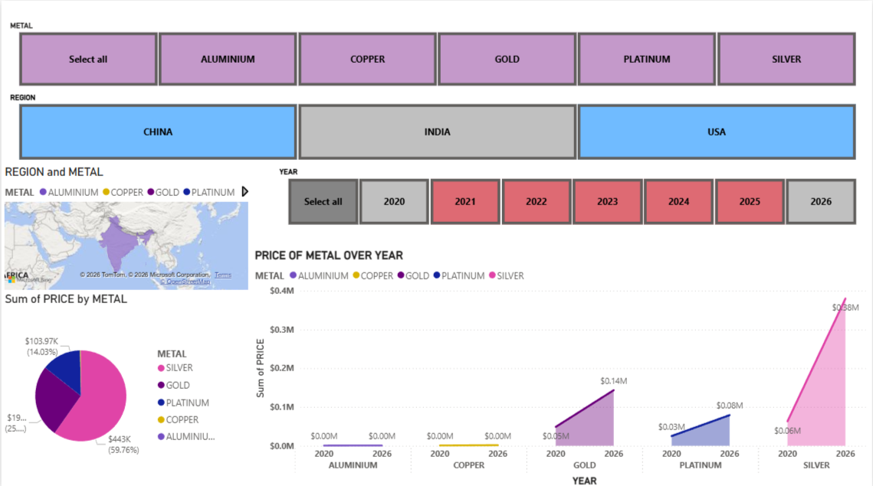

TOP 5 METAL IN USA
- GOLD
- RHODIUM
- IRIDIUM
- PLATINUM
- PALLADIUM

METAL | 2020 PRICE | 2026 PRICE | Growth % (2020–26)
 | $1,771 | $5,265 | ≈197%
  Gold
 | $6,000 | $10,775 | ≈80%
  Rhodium
Iridium | $1,500 | $6,450 | ≈330%
 | $883 | $2,766 | ≈213%
  Platinum
 | $2,193 | $2,081 | ≈-5%
  Palladium

Individual Metal Analysis (USA)
Gold — ~197% Growth
- Nearly 3× increase in 6 years
- Driven by:
  - Inflation
  - Geopolitical uncertainty
  - Central bank accumulation
- Strong safe-haven asset even in USD terms

Rhodium — ~80% Growth (Very Volatile)
- Extreme price spike in 2021 due to supply shortage
- Sharp correction in 2023–2024
- 2026 recovery driven by auto-catalyst demand
- High risk, high volatility, not suitable for conservative investors

Iridium — ~330% Growth (Best Performer)
- Strong demand from:
  - Electronics
  - Hydrogen & green energy technologies
- Very limited supply → sharp price rises
- Best performing metal in USA dataset

Platinum — ~213% Growth
- Growth accelerated after 2024
- Increased usage in:
  - Hydrogen fuel cells
  - Automotive catalysts
- Good long-term industrial + investment metal

Palladium — ~5% Decline
- Demand reduced due to:
  - Shift from palladium to platinum
  - EV adoption
- High prices in 2020–21 not sustained
- Underperformed compared to other precious metals

Ranking Based on Growth (USA)
- Iridium — ~330%
- Platinum — ~213%
- Gold — ~197%
- Rhodium — ~80%
- Palladium — ~−5%

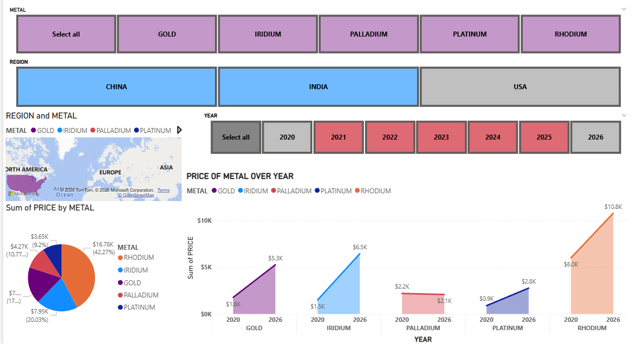

TOP 5 METAL IN CHINA
- Gold
- Rhodium
- Iridium
- Platinum
- Silver

METAL | 2020 PRICE | 2026 PRICE | Growth % (2020–26)
 | ¥395 | ¥1134 | ≈187%
  Gold
 | ¥1350 | ¥2408 | ≈78%
  Rhodium
Iridium | ¥370 | ¥1512 | ≈309%
 | ¥205 | ¥588 | ≈187%
  Platinum
 | ¥4.40 | ¥29.20 | ≈564%
  Silver

Individual Metal Analysis (China)
Gold — ~187% Growth
- Strong price appreciation due to:
  - Inflation concerns
  - Rising domestic investment demand
  - Central bank accumulation
- Acts as a safe-haven asset in China during economic uncertainty

Rhodium — ~78% Growth (Highly Volatile)
- Extreme price spike in 2021 due to supply constraints
- Sharp correction in 2023–2024
- Partial recovery by 2026
- High risk metal, not suitable for conservative portfolios

Iridium — ~309% Growth
- Strong demand from:
  - Electronics
  - Semiconductor manufacturing
  - Hydrogen energy sector
- Very limited global supply
- One of the best-performing rare metals in China

Platinum — ~187% Growth
- Demand supported by:
  - Hydrogen fuel cells
  - Automotive catalytic converters
- Lower volatility compared to rhodium
- Balanced industrial + investment metal

Silver — ~564% Growth (Highest Performer)
- Top-performing metal in China
- Massive industrial demand from:
  - Solar panels
  - Electronics
  - Green energy transition
- High volatility but exceptional long-term returns

Ranking Based on Growth (China)
- Silver — ~564%
- Iridium — ~309%
- Gold — ~187%
- Platinum — ~187%
- Rhodium — ~78%

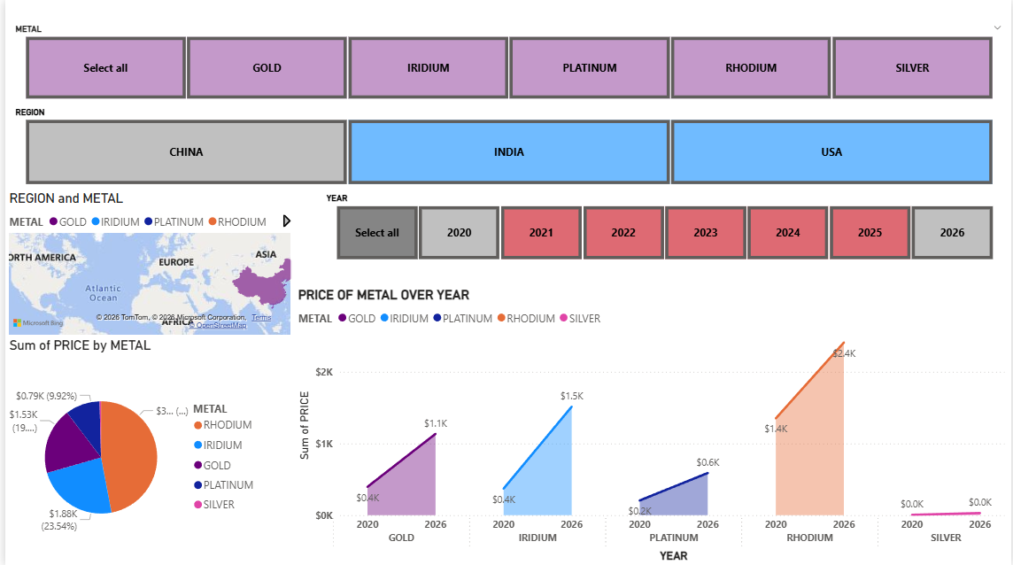

STOCK MARKET ANALYSIS
1. Top Performing Midcap Stocks (Past 1 Year)
Midcaps provided the best balance of safety and growth. Stocks in Defence, Finance, and Power dominated the charts

Stock Name | Sector | Approx. 1-Year Return
Mazagon Dock | Defence/Shipbuilding | +115%
Muthoot Finance | Conusmer Finance | +85%
Solar Industries | Defence/Explosion | +39%
Deepak Nitrate | Specialty Chemicals | +28%
Polycab India | Electrical Goods | +20%

LAST 1 YEAR PERFORMANCE BY TOP 5 MID LEVEL STOCK
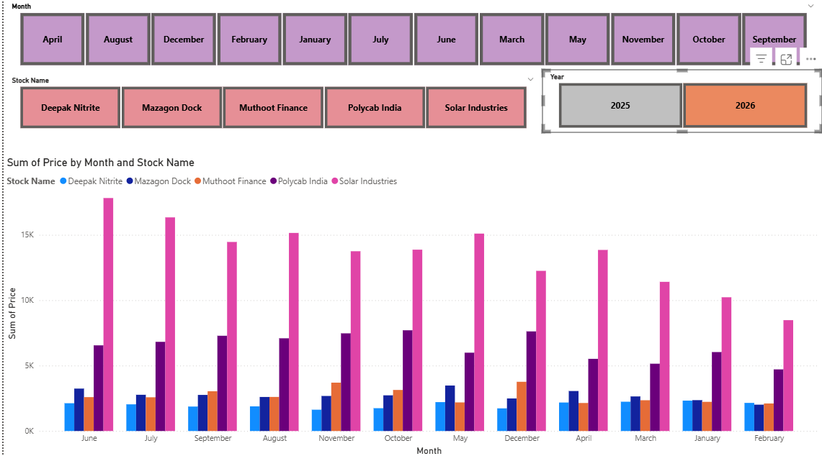

IN JAN 2026 BY TOP 5 MID LEVEL STOCK
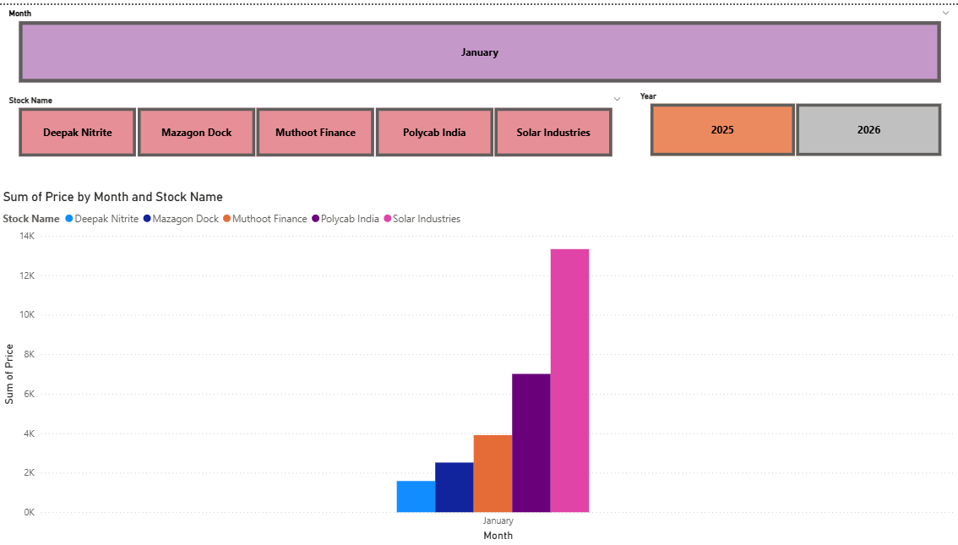

2. Top Performing Small Cap Stocks (Past 1 Year)
Small caps were highly volatile. The winners were largely those linked to Renewable Energy and AI-driven IT solutions

Stock Name | Sector | Approx. 1-Year Return
R M Drip & Sprinklers | Agri-Infrastructure | +32%
Waaree Renewables | Green Energy | +22%
Tips Music | Media & Entertainment | +20%
Bliss GVS Pharma | Pharmaceuticals | +13%
K.P.I. Green Energy | Renewable Energy | +11%

LAST 1 YEAR TOP 5 SMALL CAP STOCKS

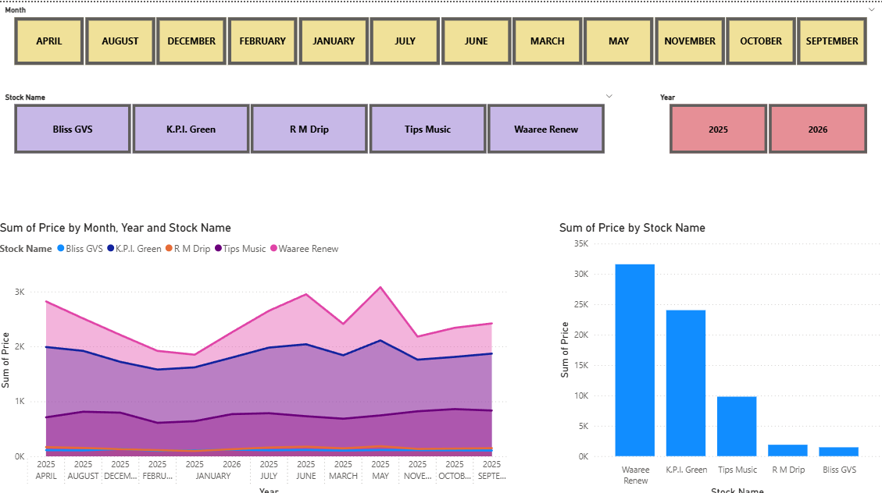

IN JAN 2026 5 SMALL CAP STOCKS

